BALLYMAHON MUNICIPAL DISTRICT

Corporate Affairs,
Aras an Chontae,
LONGFOIRT.

18th June 2015.

To: Each Member of Ballymahon Municipal District.

Dear Member,

You are requested to attend Meeting of Ballymahon Municipal District to be held in Ballymahon Community Library, on Thursday, 25th June 2015 at 5.00 p.m. (following the Annual Meeting) to transact business, as set out on the Agenda hereunder.

Yours sincerely,
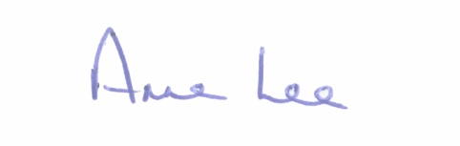

_______________
Anne Lee,
Meetings Administrator.

AGENDA

Prayer before meeting.

1. Confirmation of Minutes of Meeting of Ballymahon Municipal District held on the 28th May 2015 - copy enclosed.

2. Matters arising from Minutes.

3. Casual Trading in Ballymahon.

4. Notice of Motion submitted by Councillor Mick Cahill.

“That Ballymahon Municipal District area be considered as part of the Regeneration Project for County Longford.”

5. A.O.B.

